**Project Management - Online E-commerce System**

**Executive Summary**

This project management plan demonstrates Agile methodology implementation for an Online E-commerce System using Scrum framework. The project consists of 42 story points distributed across 3 sprints, with a 4-member team delivering incremental functionality over 6 weeks.

**1. Product Backlog (User Stories)**

|  |  |  |  |  |
| --- | --- | --- | --- | --- |
| **ID** | **User Story** | **Story Points** | **Priority** | **Sprint** |
| US01 | As a customer, I want to create an account so that I can track my orders | 5 | High | Sprint 1 |
| US02 | As a customer, I want to log in with my email and password so that my data is secure | 3 | High | Sprint 1 |
| US03 | As a customer, I want to browse products by category so that I can easily find what I'm looking for | 5 | High | Sprint 1 |
| US04 | As a customer, I want to add products to my cart so that I can purchase multiple items at once | 5 | Medium | Sprint 2 |
| US05 | As a customer, I want to view my shopping cart so that I can review items before checkout | 3 | Medium | Sprint 2 |
| US06 | As a customer, I want to checkout using multiple payment methods so that I can pay conveniently | 6 | High | Sprint 3 |
| US07 | As a customer, I want to receive an order confirmation email so that I know my purchase was successful | 2 | Medium | Sprint 2 |
| US08 | As an admin, I want to add/edit/remove products so that I can manage the catalog | 5 | High | Sprint 3 |
| US09 | As an admin, I want to view sales reports so that I can analyze business performance | 3 | Low | Sprint 3 |
| US10 | As a customer, I want to track my order status so that I know when my product will arrive | 5 | Medium | Sprint 2 |

**Total Project Scope:** 42 story points across 3 sprints

**2. Team Structure & Capacity**

**Team Composition (4 members):**

* **Scrum Master – Priya:** 2 story points per sprint (coordination, planning)
* **Developer 1 – Ramesh:** 5-6 story points per sprint (backend development)
* **Developer 2 – Sita:** 4-5 story points per sprint (frontend development)
* **Tester – Deepa:** 3-4 story points per sprint (testing activities)

**Total Team Capacity:** 14 story points per 2-week sprint

**3. Sprint Planning & Distribution**

**Sprint 1 (13 story points) - Foundation Sprint**

**Duration:** 2 weeks

**Goal:** Core user authentication and product browsing

**Selected Stories:**

* Account Creation (5 points)
* Login (3 points)
* Browse Products (5 points)

**Sprint 1 Tasks:**

* Set up project environment (1 day) → Ramesh
* Create database schema for users/products (2 days) → Ramesh
* User registration form (2 days) → Sita
* User login functionality (2 days) → Sita
* Product listing page with categories (3 days) → Ramesh
* Write unit tests (2 days) → Deepa
* Sprint review & documentation (1 day) → Priya

**Sprint 2 (14 story points) - Shopping Experience Sprint**

**Duration:** 2 weeks

**Goal:** Cart functionality and order management

**Selected Stories:**

* Confirmation Email (2 points)
* Add to Cart (5 points)
* View Cart (2 points)
* Track Order (5 points)

**Sprint 3 (14 story points) - Advanced Features Sprint**

**Duration:** 2 weeks | **Goal:** Payment processing and admin functionality

**Selected Stories:**

* Checkout (6 points)
* Admin Manage Products (5 points)
* Admin Reports (3 points)

**4. Kanban Board Implementation**

**Board Structure:**

**Columns:** To Do → Doing → Done

**Trello Board Evidence:**

The project was successfully tracked using Trello with the following progression:

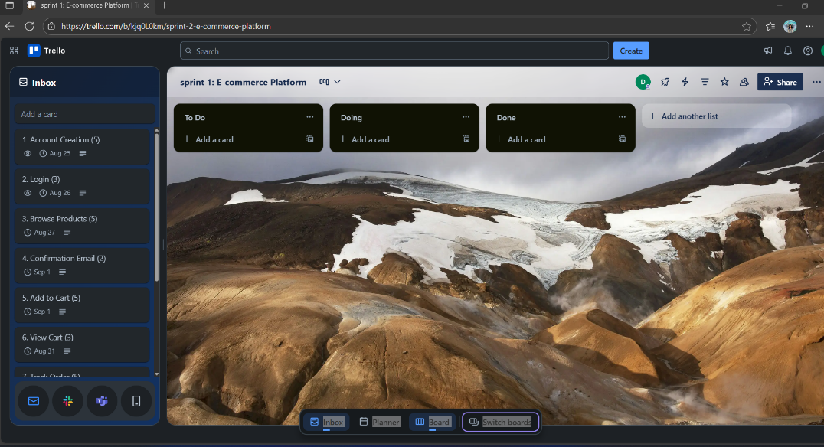

*Fig 1: Trello backlog showing user stories*

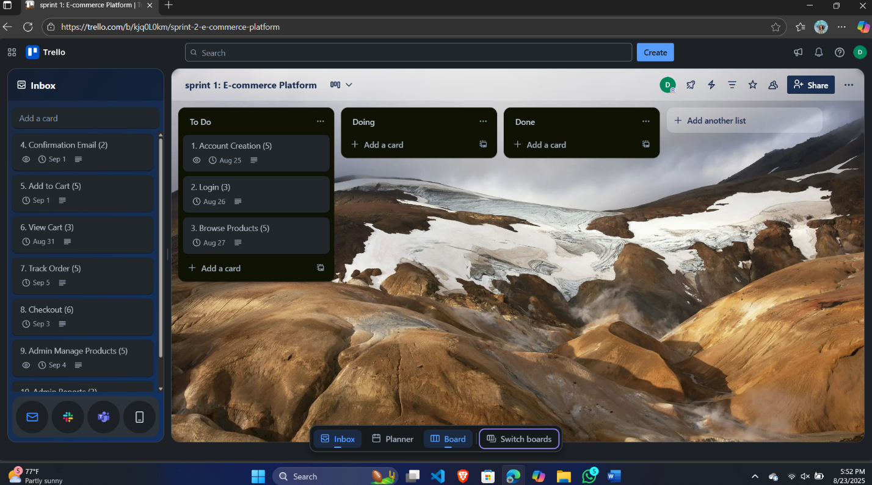

*Fig 2: Task moved to ‘To Do’ list by calculating story points in a single Sprint*

**Screenshot 1 (Sprint Start):** All Sprint 1 tasks in "To Do" column

* Account Creation (5 pts)
* Login (3 pts)
* Browse Products (5 pts)

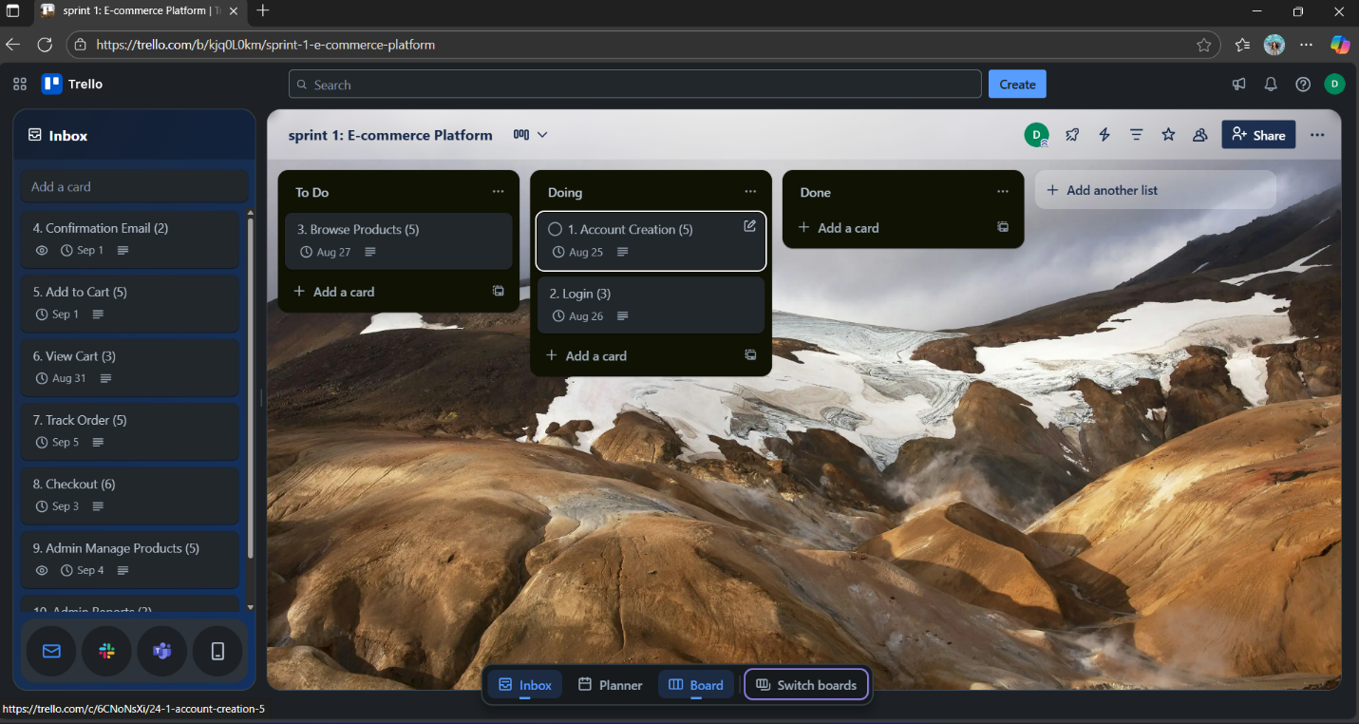

*Fig 3: Two tasks moved to ‘In Progress’ list, each for a resource to carry out*

**Screenshot 2 (Sprint in Progress):** Tasks moved to "Doing" column

* Account Creation task actively being worked on
* Demonstrates proper workflow management

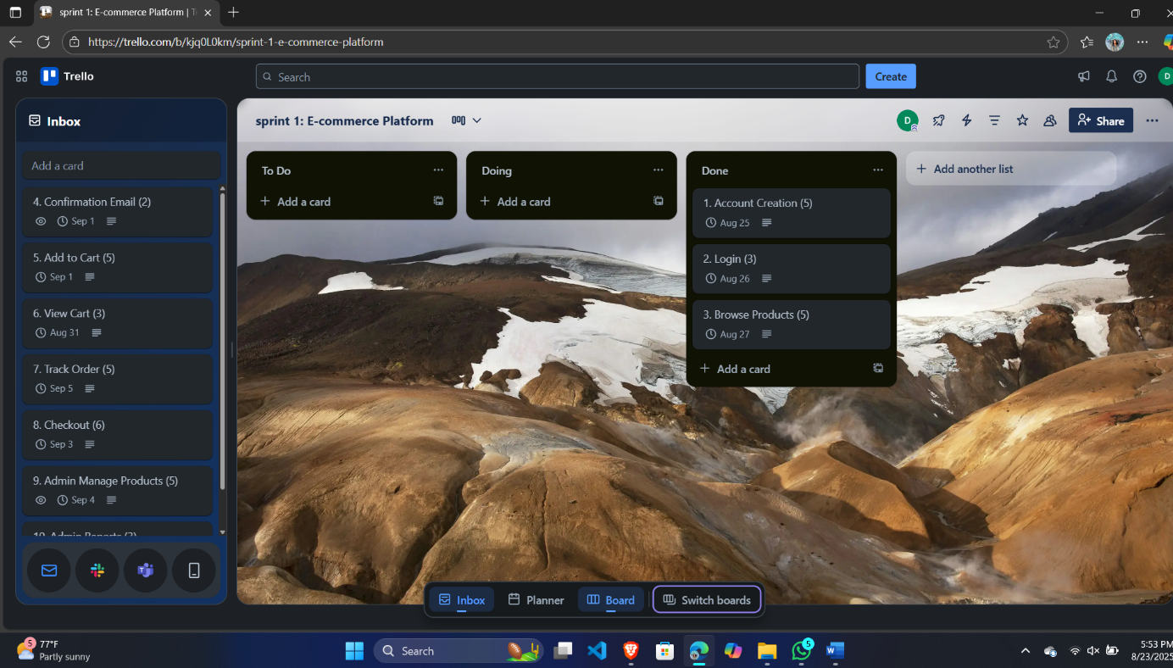

*Fig 4: Tasks moved to ‘Done’ list after being completed at the end of the Sprint*

**Screenshot 3 (Sprint Completion):** All Sprint 1 tasks in "Done" column

* All 13 story points successfully delivered
* Sprint completed within 2-week timeframe (Aug 25-27)

**Sprint 2:**

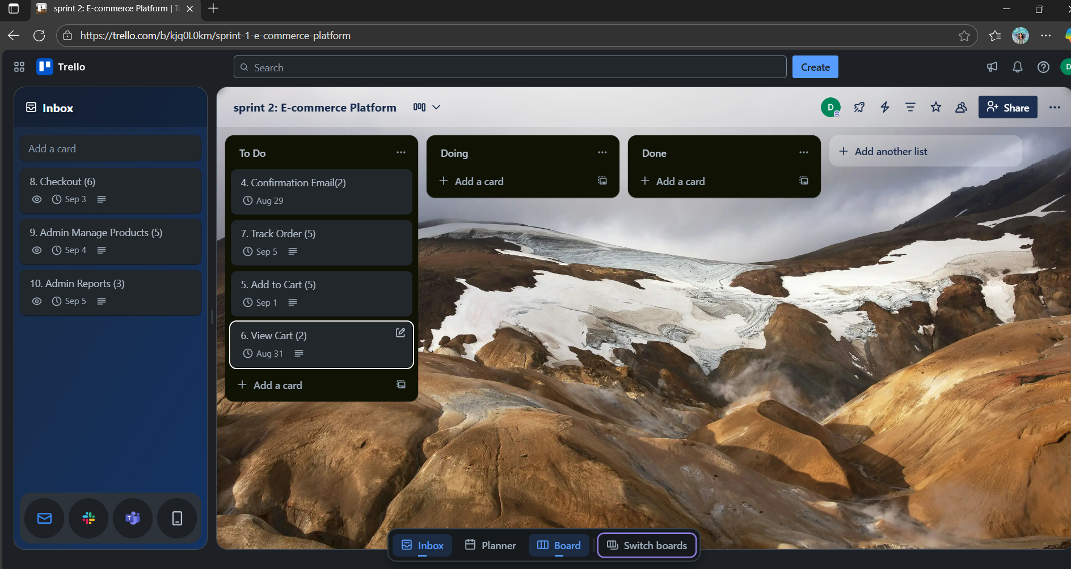

*Fig 5: Remaining tasks progressed to the next Sprint*

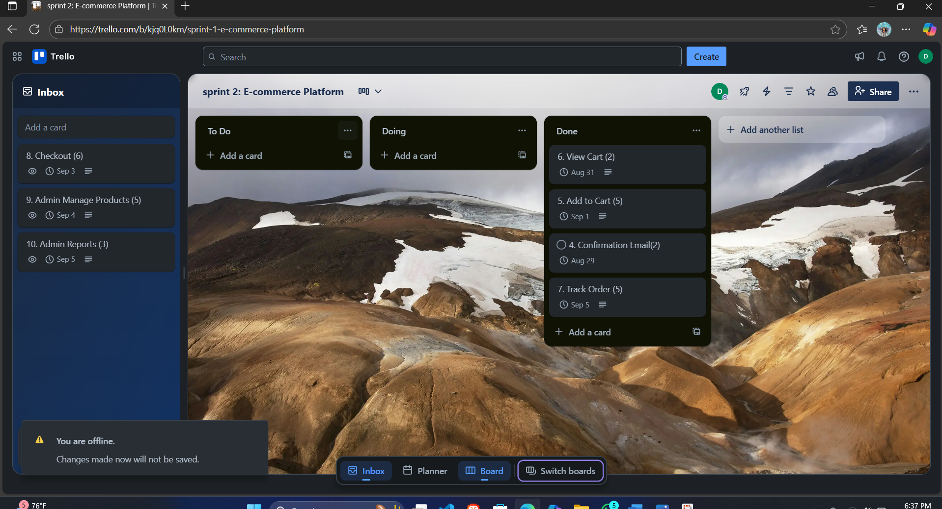

*Fig 6: Remaining tasks moved to ‘Done’ list after being completed*

**Sprint 3:**

Other all Checkout Admin Manage Products Admin Reports is moved to sprint 3 .

**5. Sprint Planning Justification**

**Capacity Planning Rationale:**

The sprint capacity of 13-14 story points per sprint is realistic because:

1. **Team Experience:** 4-member team with defined roles and responsibilities
2. **Sprint Duration:** 2-week sprints allow adequate time for development and testing
3. **Story Complexity:** Mix of simple (2-3 points) and complex (5-6 points) stories
4. **Incremental Delivery:** Each sprint delivers working software functionality
5. **Risk Management:** Buffer capacity prevents overcommitment

**Sprint Objectives Alignment:**

* **Sprint 1:** Core user functionality (authentication + browsing)
* **Sprint 2:** Shopping experience (cart + order tracking + notifications)
* **Sprint 3:** Advanced features (payment + admin functionality)